TABLE OF CONTENTS

Experiment 1: Calculations in the laboratory Experiment 2: Measurements of length and mass Experiment 3: Trigonometry
Experiment 4: Laboratory on graphing Experiment 5: Motion with constant acceleration Experiment 6: Simple harmonic Motion Experiment 7: Simple machines
Experiment 8: Conservation of energy Experiment 9: The lever
Experiment 10: Electrostatics

EXPERIMENT 1 CALCULATION IN THE LABORATORY
Purpose: The purpose of this experiment is to learn to use a calculator in order to perform your calculations in the laboratory.

All answers must be given in scientific notation to three significant figures.

- Basic arithmetic operations

 | Problem | Answer in Scientific Notation
1 | (5.97)(3.25)=
2 | (245)(983)=
3 | (2.93)(6.75)(5.93)=
4 | 7.5/3.8=
5 | 0.05/932=
6 | (9.47)(6.39)/7.42=
7 | (9.75x10⁵)(2.73x10⁻⁸)=
8 | (5.28x10³)(3.765x10⁶)(2.4x10⁻  ⁴)/(9.32)(7.54x10²)(2.00x10¹)=
9 | (7.54x10²)(4.90x10⁻⁴)/(2.50x10⁻²)(5.90x10⁻³)=

- Squares and square roots

1 | (3.52)²=
2 | (7.93)²=
3 | (259)³=
4 | (754)=
5 | (92.5)=
6 | ( (7.52)²+(9.37)²)=
7 | ( (84.3)²+(23.9)²)=
8 |  ( (3.57)²+(7.29)²)=

Trigonometric functions

1 | Sin 32⁰=
2 | Sin 150⁰=
3 | Sin 82.5=
4 | ❑ = Sin⁻¹(0.795)= | Degrees
5 | ❑ = Sin⁻¹(-0.231)= | Degrees
6 | ❑ = Sin⁻¹(-0.47)= | Degrees
7 | Cos 15⁰=
8 | Cos 75.6⁰=
9 | Cos 53.5⁰=
10 | ❑ = Cos⁻¹(0.95)= | Degrees
11 | ❑ = Cos⁻¹(0.15)= | Degrees
12 | ❑ = Cos⁻¹(0.54)= | Degrees
13 | Tan 30⁰=
14 | Tan120⁰=
15 | Tan55⁰=
16 | Tan90⁰=
17 | ❑ = Tan⁻¹(0.653)= | Degrees
18 | ❑ = Tan⁻¹(-0.198)= | Degrees
19 | ❑ = Tan⁻¹(3.47)= | Degrees
20 | ❑ = Tan⁻¹(8.25)= | Degrees

Miscellaneous functions

1 | (2)⁵ =
2 | e 1.5 =
3 | Ln 2 =
4 | Log 2=
5 | (6) ^{1/8} =
6 | 1/7.54 =
7 | 1/0.0254 =
8 | 1/935 =
9 | (3.72)³ =
10 | (154)³ =
11 | (7582) ^{1/3} =

EXPERIMENT 2 MEASUREMENTS OF LENGTH AND MASS

The application of physics always requires measurement of some kind. Being a quantitative experimental science it is as such a science of measurement.

In this experiment the dimensions of various objects will be measured by means of A ruler, a vernier caliper, and a micrometer.

The Vernier Caliper:
The vernier caliper consists of a fixed part and a movable jaw. The fixed scale is divided into centimeters, and the movable jaw has a vernier scale engraved on it. The length of each vernier division is 9/10 the length of a main scale division.
A measurement is made with the vernier caliper by closing the jaws on the object to be measured and then reading the position where the zero line of the vernier falls on the main scale.

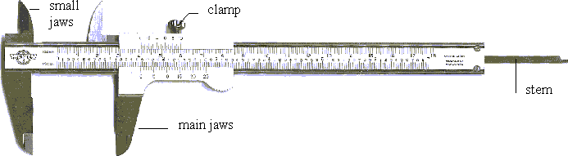

Vernier caliper readings

THIS PAGE NEEDS THE TABLES OF THE CALIPER READINGS.

The Micrometer caliper
This is an instrument used for accurate measurements of short lengths. The object to be measured is gently gripped between the two jaws of the instrument. Micrometer calipers can measure to the nearest ten-thousandth of an inch (0.002 mm)

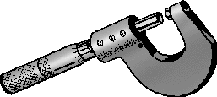

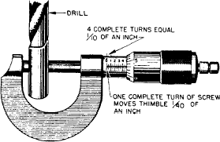

Micrometer caliper readings:

That page needs the table readings of the microcaliper readings

Data sheet

Wooden Block

Mass of wooden block 4.57g

 | Meter stick | Vernier Caliper | Micrometer caliper
Length (cm) | 2.1 | 2.02 | 2.005
Width (cm) | 1.9 | 1.87 | 1.906
Thickness (cm) | 6.85 | 6.90 | 6.880
Volume (cm³)  L x W x T | 27.332 | 26.064 | 26.292
Density (g/cm³) | 0.167 | 0.175 | 0.174

Metal Cylinder

Mass of metal cylinder = 85.75g

 | Meterstick | Vernier caliper | Micrometer Caliper
Diameter (cm) | 2.3 | 2.34 | 2.364
Height (cm) | 2.4 | 2.54 | 2.506
Volume (cm³)  (d²/4) x H | 9.98 | 10.93 | 11.00
Density (g/cm³) | 8.59 | 7.85 | 7.80

Wire Specimen

Diameter of wire =------------mm Cross sectional area of wire = mm²
(  d²/4)

EXPERIMENT 3 TRIGONOMETRIC MEASUREMENT

Purpose: The purpose of this experiment is to measure the angles and sides of a right triangle and to compare these values to the corresponding values calculated by using trigonometry.

Angle measurement

Angles are measured with a protractor.

A protractor is an instrument used to find the degree measure of an angle. It is numbered in degrees from 0 to 180 to correspond to angles which are less than or equal to half of a complete rotation. A protractor is used by placing it on the angle so that the centre point is on the vertex and the zero line is along one side of the angle. Follow the scale beginning at zero and read the measure of the angle where the other side of the angle intersects the scale on the protractor.

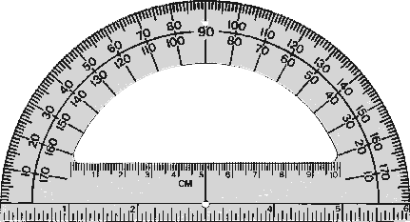

Experimental set-up
A
B C

DEFINITIONS:

Sine θ = Opposite side/Hypotenuse, Cosine θ = Adjacent side/Hypotenuse, the hypotenuse being the longest side of the right triangle.

DATA SHEET

Experimental Measurement of the angles and sides of a right triangle

Side of triangle | a (cm) | b (cm) | c (cm)
Measured | 7 | 6 | 9

Angle A

Measured by protractor | 50 | Degrees

Computed by A = sin⁻¹(a/c)7/9 | 51.06 | Degrees
Computed by A = cos⁻¹(b/c) | 48.19 | Degrees
Computed by A = tan⁻¹(a/b) | 49.4 | Degrees
Average of computed values | 49.55 | Degrees
Difference between measured and  computed values | 50-49.55=0.45 | Degrees

Angle B

Measured by protractor = | 40 | Degrees
Computed by B=sin⁻¹(b/c) = | 41.8 | Degrees
Computed by B=cos⁻¹(a/c) = | 39.0 | Degrees
Computed by B=tan⁻¹(b/a) = | 40.60 | Degrees
Average of computed values | 40.47 | Degrees
Difference between measured and computed values = | 0.47 | Degrees

Determination of the sides of a right triangle when the Hypotenuse and one angle are measured

Angle B measured = 40 degrees Hypotenuse c measured= 9 (cm)

 | Measured | Computed by a = c cosB | Difference between measured and  computed value
Side a (cm) | 7 | A=cCos40=6.90 | 0.1

 | Measured | Computed by b = c cos A | Difference between measured and  computed value
Side b (cm) | 6 | B=cCos50=5.79 | 0.21

Determination of the hypotenuse and angles of a right triangle when the sides are measured

Side a measured = 7 cm Side b measured= 6cm

 | Measured | Computed by C =  ((a)²+(b)²) | Difference between  measured and computed value
Side c (cm) | 9 | 9.22 | 0.22

 | Measured | Computed by B = tan⁻¹(b/a) | Difference between measured and  computed value
Angle B (degrees) | 40 | 40.60 | 0.60

Indirect Measurement of heights by trigonometry Example: measurement of the height of a tree.

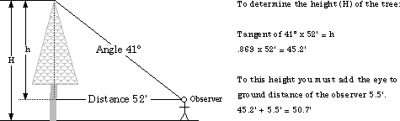

Application: Measurement of the height of a building or wall.

You are standing a distance “a” from a building or wall; measure the angle of elevation using a protractor and fill out the table below.
The measured height h0 is the observer’s eye to ground distance.

Elevation Angle  (degrees )  | Measured length: a | Side b (cm) Computed by  b = a tan  | Measured Height  h0 (m) | Height of building  h = h0 + b (m)
70 | 3 | 3tan70=8.2 | 1.5 | 9.7
54 | 6 | 6tan54=8.3 | 1.5 | 9.8
37 | 11 | 11tan37=8.3 | 1.5 | 9.8

Average height of building h= [9.8+9.8+9.7]/3= 9.77m

EXPERIMENT 4 LABORATORY ON GRAPHING

PART I

Use the x vs. t graph next page to find the value of the vertical axis intercept and the slope of the line. Notice that the vertical axis has units of meters (m) and the horizontal axis has units of seconds (s).

Find the vertical axis intercept. For this graph, this is a value of x where t=0.What is this value, including its units?
Intercept = 5

2. Find the slope
First, pick two points on the graph; designated by the coordinates (t1,x1) and (t2,x2), and write down their values, including their units. Pick these points so that their coordinates are convenient to read from the axes and so that the points are far apart.

t1=2 t2=4

x1=10 x2=15

Find the change in the coordinates,
the rise x = x2 - x1=15-10=5
and the run
t=t2 - t1=4-2=2 including units.

Calculate the slope
slope=x/t=5/2=2.5m/s
Include the units of the rise and run.

This is a graph of position vs. time for an object moving at constant velocity. The position of such an object is described by the equation x=x0+vt. Notice that the intercept is the initial position x0 and the slope is the velocity v. Write the equation for this graph by substituting your values for x0 and v (include units).

x=5+2.5t

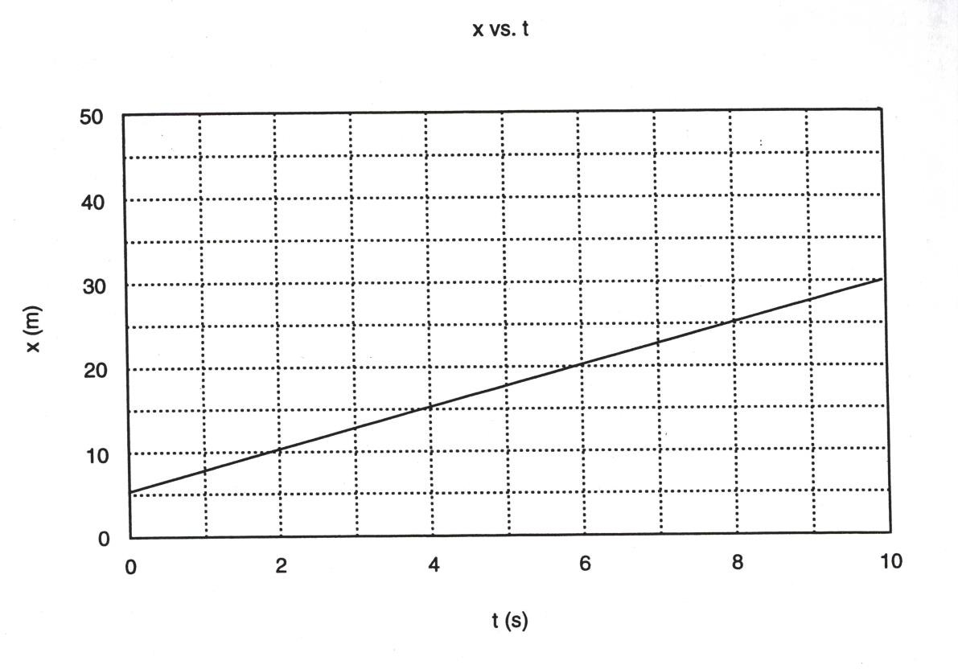

PART II

Examine the equations I-III below. What kind of curve does each of these equations represent when graphed? Write down your prediction next to each equation.
Your Prediction

Y=2x+3 linear equations
Y= x² quadratic
Y=1/x parabola/inverse

complete the following table for these three functions. Make a y vs. x graph for each function from the table.

X | Y=2x +3 | Y=x² | Y=1/x
-10 | -17 | 100 | 1/-10
-9 | -15 | 81 | 1/-9
-8 | -13 | 64 | 1/-8
-7 | -11 | 49 | 1/-7
-6 | -9 | 36 | 1/-6
-5 | -7 | 25 | 1/-5
-4 | -5 | 16 | 1/-4
-3 | -3 | 9 | 1/-3
-2 | -1 | 4 | -1/2

-1 | 1 | 1 | -1
0 | 3 | 0 | undefined
1 | 5 | 1 | 1
2 | 7 | 4 | 1/2
3 | 9 | 9 | 1/3
4 | 11 | 16 | 1/4
5 | 13 | 25 | 1/5
6 | 15 | 36 | 1/6
7 | 17 | 49 | 1/7
8 | 19 | 64 | 1/8
9 | 21 | 81 | 1/9
10 | 23 | 100 | 1/10

PART III. Searching for a linear relationship

You can gain insight into the relationship between sets of data by plotting them. The easiest relationship to judge is a linear one.

Below are two tables of data taken from a hypothetical experiment. These values might have some error in them. Make a plot of these data sets and find the best smooth curves that fit the data. Plot on separate graphs.

Data set 1: s vs. t Data set 2: v vs. t

s(m) | t(s) | v (m/s) | t(s)
0.00 | 0.0 | 0.00 | 0.0
0.17 | 1.6 | 0.185 | 1.0
0.50 | 2.4 | 0.336 | 2.0
0.69 | 3.0 | 0.427 | 3.0
1.00 | 3.5 | 0.583 | 4.0
2.00 | 5.0 | 0.792 | 5.0
6.2

Do either of these graphs show evidence of a linear relationship? Remember, there is probably some error in the data, but if the relation is linear, the data points should cluster along a straight line. If one of the graphs appears to be a straight line, draw that line.
A linear graph has a slope and y-intercept.
Data sheet 1
The data set 1 shows evident linear relationship

What is the y-intercept =0.55m

Gradient=0.33/0.8=0.41
equation of the line (y=mx+c)
where m=gradient, c is the y intercept
s=0.41-0.55

Data sheet 2
the data set 1 shows an evidence of linear relationship
y-intercept = 0m/s
gradient = (1-.0.5)m/s/(6.5-3.5)m/s = 0.17

equation of the line (y=mx+c)
where m=gradient, c is the y intercept
v=0.17t+0

EXPERIMENT 5

MOTION WITH CONSTANT ACCELERATION

Introduction.

If a body has an initial velocity v0 and undergoes a constant acceleration a over a time period t, the body will experience a displacement s given by:

s=v0t+(1/2)at²

You should recognize this as a quadratic expression; thus, a plot of s vs. t yields a segment of a parabola.

We wish to measure the acceleration of a body, from the data of its position, as a function of time. It is easier to extract information from a straight-line graph than a parabola. Can we generate a straight line from such data?

A graph of s vs. t² would not produce a straight line. To see this, notice that if the equation for displacement s is divided by time t we get

s/t=v0+(1/2)at

This equation tells us that graph of s/t vs. t has a vertical axis intercept equal to v0 and a slope equal to (1/2)a. Thus, the acceleration is twice the slope of the line. See the figure shown.

s/t
Rise
Run

t

Slope= (rise/run) = (1/2)a

PART I

The following table is a record of the displacement of an object as a function of time, where the object's initial speed is 5.0 m/s and its acceleration is 0.2 m/s². We claimed that a graph of s vs. t² would not produce a straight line. Construct a graph of s vs. t² to demonstrate this.

t(s) | s(m) | s/t (m/s) | t² (s²)
0.0 | 0.0 | ……. | 0.0
1.0 | 5.1 | 5.1 | 1.0
2.0 | 10.4 | 5.2 | 4.0
3.0 | 15.9 | 5.3 | 9.0
4.0 | 21.6 | 5.4 | 16.0
5.0 | 27.5 | 5.5 | 25.0
6.0 | 33.6 | 5.6 | 36.0
7.0 | 39.9 | 5.6 | 49.0
8.0 | 46.4 | 5.8 | 64.0

9.0 | 53.1 | 5.9 | 81.0
10.0 | 60.0 | 6.0 | 100.0

Now construct a graph of s/t vs. t to demonstrate that a graph of these data is a straight line. (Note: do not calculate s/t at t=0.0 s)
Find the slope and vertical axis intercept of your s/t vs. t graph (remember, do not use data points). The intercept and the slope have units; include the units in your calculation of the slope.
y-intercept=5.0 (m/s)
gradient [(5.55-5.35)m/s]/[(5.5-3.5)m/s] =0.1

According to the discussion on page 1, what should the values of the vertical axis intercept and the slope of the s/t vs. t graph be? Are these the same as the values you found?
Gradient =1/2a
Acceleration =2*0.1=0.2 m/s²

the results are the same

PART II.

Allow a ball to start from rest and roll down an incline plane. Time its progress at s=25, 50, 75, 100, 150, 200, 250, and 300cm.
After several runs, average the times to the nearest tenth of a second and fill in the table below.

DISPLACEMENTS AND TIMES

Displacement  s (cm) | t1 (s) | t2 (s) | t3 (s) | tav (s) | s/tav
25 | 1.50 | 1.51 | 1.52 | 1.50 | 16.7
50 | 2.10 | 2.12 | 2.13 | 2.10 | 23.8
75 | 2.70 | 2.73 | 2.71 | 2.70 | 27.8
100 | 3.10 | 3.13 | 3.14 | 3.10 | 32.3
150 | 3.80 | 3.81 | 3.84 | 3.80 | 47.4
200 | 4.40 | 4.30 | 4.40 | 4.50 | 45.5

250 | 4.90 | 5.10 | 4.90 | 4.90 | 51.0
300 | 5.40 | 5.50 | 5.40 | 5.40 | 55.6

Plot the graph s/t vs. t and then draw the best straight line so that the points cluster above and below that line.

4. Calculate the slope of the line by using points on the line that you have drawn. DO NOT USE PLOTTED POINTS. Show your calculation clearly and indicate all units in your calculation.
gradient= (132.4-130.8)/(1.2-0.7) = 10

What is the acceleration?
Acceleration =2*gradient
=2*10=20cm/s²
How many significant figures should your answer have? (Hint: How many significant figures are in the original data?)
4
Use the formula: s = (1/2)at² and calculate the displacement using your experimental acceleration and times.
S=0.5*6.4*0.17²=0.09
Compute the percent deviation for each calculated value.
% = (sexp - sactual)/sactual

For example: if the acceleration is 20 cm/s² and the average time for the 25-cm is say;1.3 seconds, calculate the experimental displacement;
sexp=(1/2)(20 cm/s²)(1.3)²=
16.9 cm.
Then compare this value to the expected value which is 25 cm using: (sexp - sactual)/sactual

Follow the same steps for the other displacements: 50 cm, 75 cm., etc….

(22.5-25)/25*100=-10%
(44.1-50)/50*100=-11.8%
(72.9-75)/75*100=-2.8%
(144.5-150)/150*100=-3.7%
(193.6-200)/200*100=-3.2%
(250-250)/250*100=0%
(291.6-300)/300*100=-2.8%

EXPERIMENT 6 SIMPLE HARMONIC MOTION

Simple harmonic motion is the type of motion of an object in which the acceleration is directly proportional to its displacement from its equilibrium position. The period is the time required for one complete vibration.

T = 2π√(m/k)

If the mass is pulled, the spring exerts a force on the mass that acts in the direction of returning it to the equilibrium position. The magnitude of that restoring force F is directly proportional to the elongation, since the distortion of an elastic body is proportional to the distorting force..

F = Kx

- measurement of the spring constant

Fasten a clamp to the table rod Hang the spring from the clamp
Measure the length of the spring to the nearest millimeter. This is the unstretched length L0.
record the length in table 1
Hang a 50-gm weight hanger from the spring. Measure the new length of the spring, L. record the length in table 1
Calculate the elongation of the spring, L-L0. Record in table 1

Repeat the measurement for 50-gm increments up to a total of 350 gm.
Make a graph of mass in grams vs. elongation in centimeters. You should find that a linear relationship exists between mass and elongation. Do not be concerned if the line does not go through the origin.
Measure the slope of the line in grams per centimeter. Convert this to newtons per meter. This is the spring constant K.
gradient=change in mass/change in elongation
gradient=(198-50)/(4-1)=49.33gm/cm
converting in to newton per meter,
49.33*10/1000*100=4.93N/m
Spring constant=gradient= 49.33N/M

TABLE 1: SPRING DATA

Unstretched length: L0=10cm

 | Mass (gm) | Length (cm)  L | Elongation (cm)  L – L0
 | 50 | 11.0 | 1.0
 | 100 | 12.1 | 2.1
 | 150 | 13.0 | 3.0
 | 200 | 13.9 | 3.9
 | 250 | 15.0 | 5.0
 | 300 | 16.1 | 6.1
 | 350 | 17.0 | 7.0

- Determination of the spring constant by measurement of the period of vibration

Hang 100 gm from the spring.
Stretch the spring by pulling the weight downward slightly from the equilibrium position.
Release the weight and start the watch simultaneously. Count 10 complete vibrations and measure the total time.
Obtain the period of vibration by dividing the total time by the number of vibrations, record in table 2.
Repeat steps 2-5 using masses of 150, 200, 250, 300, and 350 gm.

TABLE 2: VIBRATION DATA

Mass (gm) | Number of  vibrations | Total time (s) | Period T(s) | T² (s²)
100 | 10 | 13.30 | 1.33 | 1.77
150 | 10 | 20.0 | 2.00 | 4.00
200 | 10 | 26.61 | 2.66 | 7.08
250 | 10 | 33.26 | 3.33 | 11.09
300 | 10 | 39.91 | 3.99 | 15.92
350 | 10 | 46.57 | 4.66 | 21.72

- Graph T² vs m the mass, draw a best fit straight line and calculate the slope of the line.

Gradient=(275-225)/(13-9)=12.5 s²/gm

- Use K= (4π²)/(slope), and calculate the spring constant K.
K=4*22/7*22/7=39.37
K=39.37/12.5=3.16N/M

- Comparison of values

Using the value found in part A as the actual value and that of part B as experimental, calculate the percent error.
(4.93-3.16)/3.16=0.36

Kactual – Kexperimental/Kactual

EXPERIMENT 7

MACHINES: THE INCLINED PLANE
The inclined plane is mostly used to move heavy things up into something. The longer the slope of the inclined plane is; the easier it is to pull or push the heavy object up the inclined plane

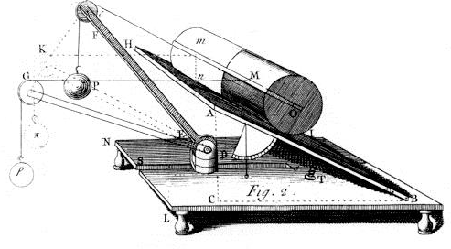

Desaguliers, Jean-Théophile, A Course of Experimental Philosophy, London, 1734, Vol. I, p. 108, Pl. 11, Fig. 2.

Frictional forces play important roles in our lives, making it possible for us to walk across a floor, for example, and requiring large expenditures on lubricants in order to reduce its often unwanted effects. Friction is not a fundamental force but is just one manifestation of the electromagnetic force which also plays a major role in our lives.

The frictional force will take two forms: (i) static friction represented by the coefficient µs, and (ii) kinetic friction represented by the coefficient µk. In order to move the object up a plane, you must do work against gravity and quite a bit of friction.
In this experiment we will determine what those coefficients are, for a wooden block and metal cart, on a wood surface. We will also determine the mechanical advantage for that simple machine.
The secret of the plane's mechanical advantage lies in its ability to split the force of gravity into two smaller forces; one perpendicular to and one parallel to the plane. It is only the parallel force which needs to be counteracted by pushing an object laying on the plane.

Coefficients of friction of Wood Block and Metal cart on Wood surface Weigh the Wooden block. Record the weight of the block under N in Table 1.
Set the friction surface in a horizontal position with the pulley projecting beyond the table edge. Place the weighed block on the surface. Tie a string to the hook in the block and hang the string over the pulley. Adjust the pulley rod until the string is horizontal.
To determine the kinetic friction force, hang weights and tap the block to start it moving. If the block stops, more weight must be added; if the block accelerates, some weight should be removed. Continue testing until you can get the block to move at constant speed. Repeat the measurement 2 or 3 times. Record the average weight hung under Fk.
Tape a 1000-gram weight to the block. Repeat the procedure described in step 3. The entry you make under N in table 1 will be the weight of the block plus 1000 grams.
Record the average weight hung under Fk.
Calculate the coefficient of kinetic friction for the two cases and record the values under k.
Follow the procedures described in steps 1-5 to determine the rolling friction force and the coefficient of rolling friction of a metal cart on the wood surface of the friction apparatus. Record the average weight under Fr, and the coefficient of rolling friction
under k, in Table 1. The measurement should be performed for the cart alone and for the cart plus 1000 grams.

Mechanical Advantage and Work on an Inclined Plane

Set the friction surface at an angle of 15⁰.
Place the block on the surface; making sure that the string, which passes over the pulley, is parallel to the surface. Hang sufficient weight on the free end of the string so that the block moves up the plane at constant speed after it has been tapped slightly.
Repeat the measurement 2 or 3 times. Record the average weight hung under Fi (input force) in table 2. The weight of the block should be recorded under Fo (output force).

Repeat the procedure in step 2 for angles of 30⁰ and 45⁰.
Calculate the output distance do that the block moves per unit input distance di along the plane. (Use the formula d0 = di sin and take di= 1 cm). Calculate the actual mechanical advantage (IMA); calculate the input work and output work; finally, calculate the mechanical efficiency. Enter all values in Table 2.
Follow the procedures described in steps 1-4 to determine AMA, IMA, input and out put work, and efficiency, for the metal cart on the inclined surface. Enter all measured and calculated values in Table 2.

TABLE 1

COEFFICIENTS OF FRICTION OF WOOD BLOCK AND METAL CART

 | Normal  force (mass of block) | Fk (Load) | k= Fk/N | Fr | r=Fr/N
Wood block | 113 | 60 | 0.53 | N/A | N/A
Wood block  +1000 g | 1113 | 577 | 0.51 | N/A | N/A
Metal cart  alone | 700 | N/A | N/A | 14 | 0.02
Metal cart +  1000 g | 1700 | N/A | N/A | 37.4 | 0.022

TABLE 2

MECHANICAL ADVANTAGE AND WORK ON INCLINED PLANE

 | ❑  (Deg | Fi(g) Load |  | F0(g)  Block | di(cm) | do(cm) Sinθ | Fidi(g.cm) | Fo.do(g.cm) | Efficiency  F0d0/Fidi
 | )
WOOD BLOCK | 15  30  45 |  | 60  70  90 | 113  113  113 | 1 | 0.23  0.45  0.65 | 60  70  90 | 25.99  50.85  73.35 | 0.433  0.73  0.82
METAL | 15 |  | 20  33  50 | 700 | 1 | 0.23  0.45  0.65 | 20  33  50 | 161  315  455 | 8.05  9.54  9.1
CART | 30  45 |  | 20  33  50 | 700

EXPERIMENT 8

CONSERVATION OF ENERGY
Introduction:
Mechanical energy is the kinetic energy plus all of the kinds of potential energy that are present. In the absence of non-conservative forces, mechanical energy is conserved.
A system is said to be conservative if only gravitational and spring forces are present. In this experiment we will calculate the kinetic energy, potential energy , and mechanical energy to determine the efficiency of a pulley system.
Procedure
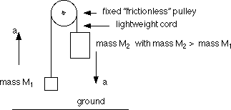

Rig up the pulley system according to direction from the instructor, using for M1 and M2; 100gm

Measure the maximum distance through which the weight hanger can fall by positioning one of the weight hangers so that it just touch the floor and measuring the distance from the floor to the bottom of the other weight hanger.

Place a 7-gram slotted weight on one of the weight hangers. Measure the time it takes to fall the maximum distance to the floor, starting from rest. Repeat the measurement several times and take an average.

Repeat step 3 for excess weights of 10 and 15grams.

Calculate the initial potential energy of the greater mass and the final potential energy of the smaller mass, relative to the floor, in each case.
Potential Energy (PE) = mgh

From the measured times of fall, calculate the final speed of the system (just before impact) in each case. Calculate the final kinetic energy of the greater mass and of the smaller mass in each case.

Kinetic Energy (KE) = (1/2)mv²
To calculate the velocity, use the following formula: V=at, where “a” the acceleration is calculated using: a=2h/t²

8. Enter the values in the tables provided. Determine the initial and the final mechanical energy, and the energy loss. Express the energy loss as a percentage of the initial mechanical energy.
Mechanical Energy = (PE) + (KE)
Discussion and data
Mass1=100g=0.100kg
Mass2=107g, 0.107kg
Height=30cm=0.3m
Time of fall=3sec
Acceleration=2x0.3/9=0.067m/s²
Velocity=at=0.067x3=0.2m/s

Potential energy: mgh |  | Kinetic Energy : (1/2)mv² |  | Total Mechanical Energy KE + PE
Mass 1 | Mass 2 | Mass 1 | Mass 2 | Total Mechanical Energy KE + PE
0 | 0.107x9.8x0.3=  0.3146 | 0 | 0 | Einitial =0.300
0.1x0.3x9.8=  0.294 |  | 0.5x0.1x0.2x0.2=0.002 | 0.3x0.107x0.2x0.2=0.0021 | Efinal =0.3146
Efinal – Einitial =0.014
Energy loss

%Energy Loss = Energy loss/ Einitial

= 0.0146/3.000x100=4.9%

Table 2
M1=100
M2=110
Time=2.5 seconds
Height =0.3m
Acceleration=0.048m/s²
Velocity=0.119m/s

Potential energy |  | Kinetic Energy |  | Total Mechanical Energy
Mass 1 | Mass 2 | Mass 1 | Mass 2 | Total Mechanical Energy
0 | 0.11x9.8x0.3 | 0 | 0 | Einitial =0.3234
0.1x9.8x0.3=  0.294 | 0 | 0.5x0.1x0.119²=0.00007 | 0.5x,119²x.11=0.0007 | Efinal =0.296
 |  |  |  | Efinal – Einitial =0.0278
Energy loss

% Energy Loss =8.6%

Data

M100

M2=115

Time = 2sec

Acceleration= 0.15m/s²

Velocity= 0.3m/s

Potential energy |  | Kinetic Energy |  | Total Mechanical Energy
Mass 1 | Mass 2 | Mass 1 | Mass 2 | Total Mechanical Energy
0 | 0.3381 | 0 | 0 | Einitial =0.3381
0.294 | 0 | 0.5x0.10x0.3²=0.0045 | 0.005 | Efinal =0.3037

Efinal – Einitial =0.0344
Energy loss

%Energy Loss =11.3%

EXPERIMENT 9 THE LEVER

If one uses as a lever a perfectly balanced meter stick, one can easily investigate the relation of forces, lever arms, and torques. Assume that the meter stick is hung at its center of gravity. If a known weight is hung on the right side at a fixed position, the required weight on the left to balance the meter stick can be investigated for a number of different positions.

Ll Lr

CG
WL WR

Clearly the torques on the left and right are balanced. Thus

TL = TR WLLl = WRLr

But W = mg.

mLLl = mRLr

If mL is the unknown, then

If the balancing mass (mL) is given and the lever arm on the lever on the left is unknown, then

Ll = Lr (mR/mL)

INSTRUCTIONS FOR LEVER EXPERIMENT

Attach a string to the center of gravity of the meter stick and hang the meter stick at this point. NOTE: When the position of the string is precisely correct, the stick will remain at any arbitrary orientation. Location of C.G.:50cm

Attach loops of string to the meter stick for hanging weight hangers.

In all the masses that follow, the mass of the weight hanger must be included as part of the total mass. Also in every case find the experimental value before doing the calculations.

Experiment 1.

Take mR = 150 gm (including hanger) at Lr = 10 cm.
Find mL experimentally for Ll = 10 cm, 15 cm, 20 cm, 25 cm, 30 cm, 40 cm. Enter these results in the table.
Calculate expected values for mL and enter these in the table.
Taking the calculated values for mL as the expected values, calculate a percent of error and enter result in table.

Experiment 2.

Take mR = 100 gm at Lr = 20 cm.
Find Ll experimentally if mL = 120 gm, 110 gm, 100 gm, 90 gm, 80 gm, 70 gm, 60 gm.
Calculate expected values for Ll and enter these in the table.
Taking the calculated values of Ll as the expected values, calculate a percent of error and enter result in table.

Experiment 3. (take all loads off the meter stick)
Move the pivot to the 35 cm mark.
Find the mass needed at the 15 cm mark to balance the system:149
Calculate the mass of the meter stick:198.7 Mstick=Mload(20 cm )/15cm Weigh the meter stick:----1.98N--------------------
Taking the value from the scale as the expected value, calculate the % of error.

(200-198.7)/200x100=0.65%

TABLE 1

mR (gm) | Lr (cm) | Ll (cm) | ml (gm) Experimentally | ml (gm) Calculated | % of error
150 | 10 | 10 | 148 | 150 | 1.3%
150 | 10 | 15 | 101 | 100 | 1%
150 | 10 | 20 | 73 | 75 | 2.7%
150 | 10 | 25 | 61 | 60 | 1.7%
150 | 10 | 30 | 49 | 50 | 2%
150 | 10 | 35 | 43 | 42.8 | 0.33%
150 | 10 | 40 | 37 | 37.5 | 1.33%

Show here clearly and systematically calculations for mL and for % of error:

%error = [ Calculated – Experimental ] / Calculated x

TABLE 2

mR (gm) | Lr (cm) | mL (gm) | Ll (cm) Experimentally | Ll (cm) Calculated | % of error
100 | 20 | 120 | 16.0 | 16.7 | 4.19%
100 | 20 | 110 | 17.5 | 18.18 | 3.7%
100 | 20 | 100 | 21 | 20 | 5%
100 | 20 | 90 | 22 | 22.22 | 0.99%
100 | 20 | 80 | 26 | 24 | 4%
100 | 20 | 70 | 28 | 28.6 | 2.1%
100 | 20 | 60 | 32 | 33.33 | 3.99%

Show here clearly calculations for Ll and for % of error.

Experiment 4

Place the pivot at the 40-cm mark. Attach 50 gm at the 65-cm mark.
Find experimentally how much load is needed at the 5-cm mark to balance the system:
95gm
Calculate the load needed to balance the system.

Mload = [Mstick(10 cm) + 50 gm (25 cm)] / (35 cm)=92.9gm

Taking the value from (d) as the expected value, calculate the percent of error.
(95-92.9)/92,9x100=2.27%

EXPERIMENT 10 ELECTROSTATICS

PRINCIPLE ILLUSTRATED : Generation and interaction of electrostatic charges.

Fundamentals to remember:

Like charges repel; unlike charges attract. Electrostatics, as the name implies, deals with static charges, i.e., charges at rest. Charge must be moved to assemble it, of course. While it is true that in metals the charge carriers (electrons) are negative, one may speak of either positive or negative charge as being mobile. This is because when a negative charge is removed from a neutral object the object is left positively charged. A good conductor has many charge carriers; a good insulator has very few. These terms are relative and there is no sharp dividing line between insulators and conductors. Paraffin is one of the very few common materials, which has superior insulating qualities in both dry and humid weather.

DEMONSTRATION SET UP

Place can on paraffin block.

Attach aluminum foil vane to can as follows: (a) Hang vane bracket over edge of can.
(b) Place aluminum foil strip on smooth surface and smooth flat with finger (repeat after use to store strip!). Form strip around nail to produce hook in one end. (c) Hang strip over bracket.

The operator should be grounded to prevent static charge from building up on the body especially in dry weather. Attach the grounding wristband to the wrist and the end of the ground wire to a laboratory water faucet (use clip terminal) or a classroom receptacle or switch plate.

To "earth" an object means to touch it with a finger so that the charge on the object is transferred to ground.

"Charging the wand." To charge the metal (aluminum) end of the wand simply rub it with the plastic film (sandwich bag). More specifically, hold the acrylic end of the wand in the fingers of the right hand (normally), form the plastic around the aluminum end with the fingers of the left hand, and give the wand few gentle twists. The aluminum of the wand will be charged positively.
BASIC DEMONSTRATION

Charge the wand and touch it to the inside of the can well below the rim. Since like charges repel, the charge on the wand will flow to the outside of the can. (All excess charge resides on the outside of a conductor; none on any interior surfaces.) Repeat until the vane stands out 30⁰-45⁰ from the side of the can.

Demo: Electrostatic charge can be handled quantitatively. Earth wand. Touch wand to outside of can and notice that falls a bit when wand is removed. Explain.

Now that the wand is changed, when in contact it repels opposite which concentrate on the leaf and hence diverge. On removal, the changes reduce in numbers and hence the fall.

Demo: Like charges repel.
Earth wand. Get sample of charge on wand from the outside of the can and bring wand radially in toward vane. The vane will be repelled inward toward can. Explain.

Since the wand is charged positively and the can has positive charges, there will be a repulsive force due to the positive charges.

- Demo: Charging by induction.
Earth wand. (a) Hold wand close to charged can (about 1/8"). A charge separation in wand will be affected AS SHOWN. (c) Touch wand with finger at the aluminum-acrylic junction allowing the positive charge to run to ground. (c) This will leave the wand negatively charged. Bring the wand in toward the vane. What do you observe?

The vane will be attracted to the wand, this is because the vane is negatively charged and the wand is positively charged. The law of electrostatics states that like charges repel and unlike charges attract.

- Demo: Conductors and insulators.
The charged can is an extremely sensitive indicator of any conductivity. Paper and cotton string are normally considered good insulators but just how good depends upon moisture content. Take one end of the paper strip or string between the fingers and rest the other end on the edge of the charged can. In very dry weather the vane may not fall. In this case breathe on the strip or string to increase moisture content and try again. Many other materials can be tried, of course.

On dry weather paper and cotton are good insulators, breathing on the strip introduces moisture which is polar solvent. All polar solvents are good conductors of electricity and since electricity is the flow of charges, electrons will move from the ground through the hand to the can and neutralize the positive charges making the van to fall.

- Demo: The principle of the Van de Graaff generator.
Earth the can to be sure that it is uncharged and then begin to charge it by applying the charging wand to the outside of the can rather than to the inside. A point will be reached such that the vane cannot be made to stand out any farther. Explain.

During charging, the charge increases on the surface of the can making the vane to stand due to repulsion force, after sometime, the charge at the wand equals to the charge at the can. This creates a potential difference that cancel out the charges leaving the can neutral hence the vane falls.

